**E – LERANING PLATFORM DBMS PPROJECT**

**ABSTRACT**

**Mini-project Report**

Submitted by

**1. Muskan Sanjay Bhattad - 202001103002**

**2. Yash Daniel Ingle - 202001103032**

To the Faculty of Engineering of

Mahatma Gandhi Mission University, Aurangabad

**Under Guidance of**

Mrs. Shweta Janardan Patil



**Department of Computer Science & Engineering**

**MGM’s Jawaharlal Nehru Engineering College, Aurangabad**

**Academic Year 2021-22 Part-1**

ACKNOWLEDGEMENT

We would like to express our special thanks of gratitude to our teacher

**Mrs. Shweta Janardan Patil**, Computer Science and Engineering Department for providing encouragement, constant support, guidance and the golden opportunity to do this wonderful project on

such an interesting topic using Web Technology tools.

We were able to learn many new things in Web Technology, and get an in-depth knowledge of various advanced topics related to Web Technology, which surely will be very helpful for us in our professional journey as a Software developer. We extend our gratitude towards Jawaharlal Nehru engineering College Aurangabad and specially B-Tech CSE dept, we are really thankful for them.

Muskan Sanjay Bhattad

&

Yash Daniel Ingle

SY-CSE-1

**INDEX**

|  |  |
| --- | --- |
| **Title** | **Page No** |
| Acknowledgement | -- |
| Abstract | -- |
| Introduction | 01-06 |
| Specification | 07 |
| Implementation with output screenshot | 08-12 |
| Result | 13-14 |
| Conclusion | 15 |
| References | 16 |

**ABSTRACT**

**TITLE: E-Learning Platform**

**Group members**: -

1)Name: Muskan Sanjay Bhattad PRN: 202001103002

2) Name: Yash Daniel Ingle PRN: 202001103032

# Objectives: -

1. To create a robust learning experience that feels like a classroom experience
2. Enhance the quality of learning and teaching
3. Meet the learning style or needs of learners’ of Today’s Era
4. Improve user-accessibility and time flexibility to engage learners in the learning process – anytime anywhere

# Created for:-

1. S

# Functionality: -

1. Remote access to any desired classes – for anyone anywhere anytime
2. User friendly and intuitive learner interface with variety in learning resources
3. It promotes active and independent learning
4. High-Quality Student-Tutor Interactions plus more students can enroll at once

# Topics included

1. Online interactive video lectures of different streams/fields
2. E-books and notes for learners
3. QNA sessions or face-to-face mentor/tutor student interaction
4. Weekly assignments/tests – to keep the track of learner
5. Performance analysis report

**INTRODUCTION**

E- Learning, or electronic learning, is the delivery of learning and training through digital resources. Although eLearning is based on formalized learning, it is provided through electronic devices such as computers, tablets and even cellular phones that are connected to the internet. This makes it easy for users to learn anytime, anywhere, with few, if any, restrictions. Basically, eLearning is training, learning, or education delivered online through a computer or any other digital device.

E-Learning is the process of using technology to assist learning and tutoring. Enhancement in how the Internet works has allowed websites to deliver a visual and immersive learning experience on a computer or mobile device, perfect for stimulating a student and encouraging learning.

## **BENEFITS OF E-LEARNING: -**

* E-learning provides a single source of learning materials ensuring that the content delivered is identical for all learners and is of the highest possible quality.
* Online e-learning courses are quick and easy to update across the board without needing to spend time and money organizing and distributing paper, CD or DVD based content and materials.
* e-learning is reliable, dependable and accessible around the clock via an internet connection.
* e-learning is easy to manage and control online via our Learner Management System (LMS).
* One of the most obvious benefits is the potential to reduce costs associated with training and development of employees without the need of travel and accommodation for them at a centralized location. Because e-learning can be taken anytime, anywhere, it doesn’t interfere with critical operations of the employee.
* e-learning is standardized: every learner has access to the same high quality instruction. e-learning eliminates the problems associated with different instructors teaching slightly different material on the same subject. This also ensures all learners receive a consistent message.
* New e-learning for iPads and HTML5 means enabling your existing legacy e-learning content to be migrated to a tablet compatible format, and our solutions will help you in taking the first steps in an easy and a cost-effective way.

## **FEATURES OF E-LEARNING: -**

**SCALABLE & EFFICIENT** – E-Learning enables you to quickly create and communicate new policies, training, ideas, and concepts. Online E-Learning sessions are especially easy to keep up-to-date because the updated materials are simply uploaded to a server and can be managed from anywhere using a bespoke admin system created to your specific requirements.

**ACCESSIBILITY & TIME SAVING** – E-Learning materials are accessible at any time from any place, meaning learning can fit around your existing daily schedule and eliminate any travel costs associated with classroom-based training.

**TRACKING LEARNING ACTIVITIES** – Using a learning management system (LMS) makes it easy to track the students’ progress. We know that everyone learns at a different rate which is why we follow a modular approach, allowing modules covering familiar topics to be skipped so that you can concentrate on a less well-known subject. Full tracking capabilities are built in to provide comprehensive reports for individuals, classes, subjects and modules.

**CAPACITY & CONSISTENCY** – Using E-Learning allows educators to achieve a great degree of coverage for their target audience, and it ensures that the message is communicated in a consistent fashion. This results in all learners receiving the same training.

**How to Deliver eLearning: -**

### Using an LMS: A [learning management system](https://www.learnupon.com/blog/what-is-an-lms/) (LMS) is a software application that is used to deliver online training. Selecting an LMS can be daunting at first, but [analyzing your training needs](https://www.learnupon.com/blog/choosing-lms/) and defining your requirements, should narrow your search significantly.

### SCORM: using SCORM provides your learner with a more interactive, engaging experience, and allows you greater control over the time spent on your courses. SCORM is an acronym that stands for Shareable Content Object Reference Model.

### xAPI: xAPI is often described as the next evolution of SCORM, as it has redefined some of the fundamental practices of tracking learning experiences. It adds extra performance to SCORM and removes a lot of the restrictions of older specifications. It offers a level of flexibility that suits today’s fast-paced world. Moderns learners want to learn on-the-go; while commuting to work, or while grabbing a coffee.

## **Benefits of eLearning**

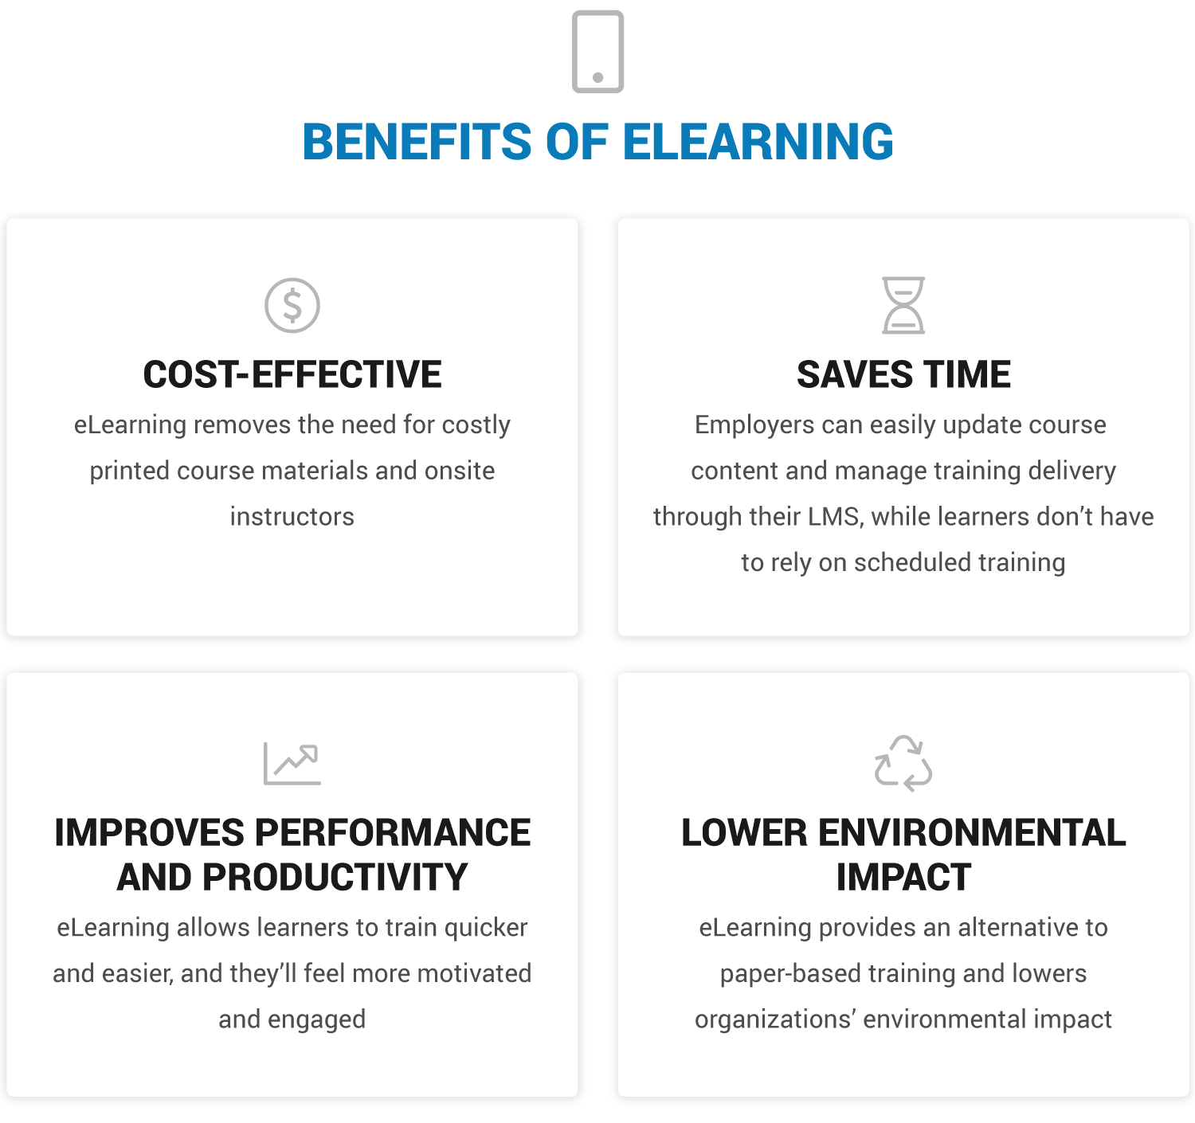

In other words, E-leraning is type of platform where user can learn from anywhere anytime according to his/her comfort. It not only saves time but also has a superior hand over traditional education system. The visual aid added to lectures make them more interesting and easier to understand.

In this project, we have created a E-learning website using html, CSS, react JS, etc. We have added different programs to it and made it as user friendly as possible to navigate and subscribe for any desired course.

**SPECIFICATION**

**Computer system specifications: -**

OS Name: Microsoft Windows 10 Home Single Language

Version: 10.0.19044 Build 19044

System Name: LAPTOP-K70O6FAG

System Manufacturer: LENOVO

Processor: Intel(R) Core(TM) i7-10750H CPU @2.60GHz, 2592 Mhz, 6 Core(s), 12 Logical Processor(s)GHz

Ram: 16.00 GB.

System: 64-bit operating system, x64-based processor.

Rom: 1 Tb SSD.

**IMPLEMENTATION & OUTPUT**

**HTML CODEs:**

**1.Home.html**

<!DOCTYPE html>

<html lang="en">

<head>

    <meta charset="UTF-8">

    <meta name="viewport" content="width=device-width, initial-scale=1.0">

    <title>home</title>

    <!-- font awesome cdn link  -->

    <link rel="stylesheet" href="https://cdnjs.cloudflare.com/ajax/libs/font-awesome/5.15.3/css/all.min.css">

    <!-- custom css file link  -->

    <link rel="stylesheet" href="css/style.css">

</head>

<body>

<div class="container">

<header>

    <a href="#" class="logo">Smart<span>Study</span></a>

    <div id="menu" class="fas fa-bars"></div>

    <nav class="navbar">

        <a href="home.html">home</a>

        <a href="course.html">course</a>

        <a href="teacher.html">teacher</a>

        <a href="price.html">price</a>

        <a href="review.html">review</a>

        <a href="contact.html">contact</a>

        <a href="signup.html">Sign Up</a>

    </nav>

</header>

<section class="home">

    <div class="content">

        <h3>E-learning is a better way of learning</h3>

        <p>

            Comprehensive learning programs

            & classes for all students

            Become lifelong learners with India's best teachers,

            engaging video lessons and personalised learning journeys

            </p>

        <a href="signup.html" class="btn">Register Now</a>

    </div>

    <div class="image">

        <img src="images/home-img.svg" alt="">

    </div>

</section>

<section class="home">

    <div class="content">

        <h3>Subscription based Model</h3>

        <p>

            A single subscription provides you with an access to all the programs that are available on the platform.

            <br>One subscription gives you privilege to get access for every extra program that is added on the Smartstudy.</br>

            Hassel free payment options!!

            </p>

        <a href="price.html" class="btn">Subscribe Now!</a>

    </div>

    <div class="image">

        <img src="images/sub_img-removebg-preview.png" alt="">

    </div>

</section>

<section class="home">

    <div class="content">

        <h3>Top classes & materials</h3>

        <p>

            Smartstudy's each class gives you a to high quality video lessons, a course workbook, certificate and class feedback.

            <br>Every class is designed with a unique learning ways to explore each topic to its finest knowledge.</br>

            </p>

        <a href="#" class="btn">get class materials</a>

    </div>

    <div class="image">

        <img src="images/topcls.jpg" alt="">

    </div>

</section>

<section class="home">

    <div class="content">

        <h3>Industry Experts</h3>

        <p>

            We are partnering with the experts to teach us regulars the secret to crack any problem and define your own unique solution.

            <br>They are the top notch of their skills and not only they will teach but also mentor each n every student.

            </p>

        <a href="teacher.html" class="btn">Meet Experts</a>

    </div>

    <div class="image">

        <img src="images/expert.png" alt="">

    </div>

</section>

<section class="home">

    <div class="content">

        <h3>Academic exellence</h3>

        <p>

            If you’re craving something to inspire you, help you hone in on a craft, or looking to get advice from a respected expert you are at the right place

            </p>

        <a href="#" class="btn">Our accreditation</a>

    </div>

    <div class="image">

        <img src="images/excl.gif" alt="">

    </div>

</section>

<!-- footer section  -->

<section class="footer">

    <div class="box-container">

        <div class="box">

            <h3>about us</h3>

            <p>Smartstudy is India's largest<br> ed-tech company and the <br> creator of India's most loved E-learning app.<br>Launched in 2020</p>

        </div>

        <div class="box">

            <h3>quick links</h3>

            <a href="home.html">home</a>

            <a href="course.html">course</a>

            <a href="teacher.html">teacher</a>

            <a href="price.html">price</a>

            <a href="review.html">review</a>

            <a href="contact.html">contact</a>

            <a href="signup.html">Signup</a>

        </div>

        <div class="box">

            <h3>follow us</h3>

            <a href="https://www.facebook.com/">facebook</a>

            <a href="https://twitter.com/home">twitter</a>

            <a href="https://instagram.com/_muskiii.___?igshid=YmMyMTA2M2Y=">instagram</a>

            <a href="https://www.linkedin.com/in/muskan-bhattad-bb73a121a">linkedin</a>

        </div>

        <div class="box">

            <h3>contact us</h3>

           <p> <i class="fas fa-phone"></i> +91 - 9518920645 </p>

           <p> <i class="fas fa-envelope"></i> studysmart@gmail.com </p>

           <p> <i class="fas fa-map-marker-alt"></i> Aurangabad, india - 431001 </p>

        </div>

    </div>

    <div class="credit"> created by <span> Yash & Muskan </span> | All @rights reserved to Smartstudy </div>

</section>

</div>

<script src="js/script.js"></script>

</body>

</html>

**2.Course.html**

<!DOCTYPE html>

<html lang="en">

<head>

    <meta charset="UTF-8">

    <meta name="viewport" content="width=device-width, initial-scale=1.0">

    <title>course</title>

    <!-- font awesome cdn link  -->

    <link rel="stylesheet" href="https://cdnjs.cloudflare.com/ajax/libs/font-awesome/5.15.3/css/all.min.css">

    <!-- custom css file link  -->

    <link rel="stylesheet" href="css/style.css">

</head>

<body>

<div class="container">

<header>

    <a href="home.html" class="logo">Smart<span>Study</span></a>

    <div id="menu" class="fas fa-bars"></div>

    <nav class="navbar">

        <a href="home.html">home</a>

        <a href="course.html">course</a>

        <a href="teacher.html">teacher</a>

        <a href="price.html">price</a>

        <a href="review.html">review</a>

        <a href="contact.html">contact</a>

        <a href="signup.html">Sign Up</a>

    </nav>

</header>

<h1 class="heading"> Our courses </h1>

<!-- course section  -->

<section class="course">

    <div class="box">

        <img src="images/eng.jpg" alt="">

        <div class="stars">

            <i class="fas fa-star"></i>

            <i class="fas fa-star"></i>

            <i class="fas fa-star"></i>

            <i class="fas fa-star"></i>

            <i class="far fa-star"></i>

        </div>

        <h3>English</h3>

        <p>This course emphasizes the fundamental language skills of reading, writing, speaking, listening, thinking, viewing and presenting. An emphasis on vocabulary and composition skills will be an on-going part of the program.</p>

        <a href="signup.html" class="btn">learn more</a>

        <div class="icons">

            <p> <i class="far fa-clock"></i> 2 hours/week </p>

            <p> <i class="far fa-calendar"></i> 6 months </p>

            <p> <i class="fas fa-book"></i> 12 modules </p>

        </div>

    </div>

    <div class="box">

        <img src="images/math.jpg" alt="">

        <div class="stars">

            <i class="fas fa-star"></i>

            <i class="fas fa-star"></i>

            <i class="fas fa-star"></i>

            <i class="fas fa-star"></i>

            <i class="fas fa-star"></i>

        </div>

        <h3>Mathematics</h3>

        <p>This course provides an introduction to basic algebraic concepts. Students will be able to apply principles of integers, variables, polynomials, exponents, factoring, and solving and graphing first-degree equations.</p>

        <a href="signup.html" class="btn">learn more</a>

        <div class="icons">

            <p> <i class="far fa-clock"></i> 4 hours/week </p>

            <p> <i class="far fa-calendar"></i> 8 months </p>

            <p> <i class="fas fa-book"></i> 15 modules </p>

        </div>

    </div>

    <div class="box">

        <img src="images/chem-removebg-preview.png" alt="">

        <div class="stars">

            <i class="fas fa-star"></i>

            <i class="fas fa-star"></i>

            <i class="fas fa-star"></i>

            <i class="fas fa-star"></i>

            <i class="far fa-star"></i>

        </div>

        <h3>Chemistry</h3>

        <p>This course gives you insights of general principles of chemistry & its related science. Stoichiometry, atomic structure, chemical bonding and geometry, thermochemistry, gases, types of chemical reactions, statistics.</p>

        <a href="signup.html" class="btn">learn more</a>

        <div class="icons">

            <p> <i class="far fa-clock"></i> 4 hours/week </p>

            <p> <i class="far fa-calendar"></i> 8 months </p>

            <p> <i class="fas fa-book"></i> 18 modules </p>

        </div>

    </div>

    <div class="box">

        <img src="images/physics.png" alt="">

        <div class="stars">

            <i class="fas fa-star"></i>

            <i class="fas fa-star"></i>

            <i class="fas fa-star"></i>

            <i class="far fa-star"></i>

            <i class="far fa-star"></i>

        </div>

        <h3>Physics</h3>

        <p>This course will help you explore motion, Newton's Laws, conservation principles (Energy & momentum), waves, thermodynamics, electricity, magnetism, optics, and modern physics. It is for students who love to gain the best understanding of physics.</p>

        <a href="signup.html" class="btn">learn more</a>

        <div class="icons">

            <p> <i class="far fa-clock"></i> 4.5 hours/week </p>

            <p> <i class="far fa-calendar"></i> 11 months </p>

            <p> <i class="fas fa-book"></i> 20 modules </p>

        </div>

    </div>

    <div class="box">

        <img src="images/bio-removebg-preview.png" alt="">

        <div class="stars">

            <i class="fas fa-star"></i>

            <i class="fas fa-star"></i>

            <i class="fas fa-star"></i>

            <i class="fas fa-star"></i>

            <i class="far fa-star"></i>

        </div>

        <h3>Biology</h3>

        <p>This course includes a study of living organisms and vital processes. Themes that will be covered in this course include scientific skills, ecology, biochemistry, cellular processes, genetics, evolution, classification of organisms, as well as plant and human body systems.</p>

        <a href="signup.html" class="btn">learn more</a>

        <div class="icons">

            <p> <i class="far fa-clock"></i> 4 hours/week </p>

            <p> <i class="far fa-calendar"></i> 9 months </p>

            <p> <i class="fas fa-book"></i> 16 modules </p>

        </div>

    </div>

    <div class="box">

        <img src="images/course-5.svg" alt="">

        <div class="stars">

            <i class="fas fa-star"></i>

            <i class="fas fa-star"></i>

            <i class="fas fa-star"></i>

            <i class="fas fa-star"></i>

            <i class="far fa-star"></i>

        </div>

        <h3>Computer science</h3>

        <p>In this course you will leran about, evolving hardware and software, using the Internet, creating web pages, social implications, and using a modern programming language. Problem solving and algorithm development are important themes of the class.</p>

        <a href="#" class="btn">learn more</a>

        <div class="icons">

            <p> <i class="far fa-clock"></i> 3 hours/week </p>

            <p> <i class="far fa-calendar"></i> 6 months </p>

            <p> <i class="fas fa-book"></i> 10 modules </p>

        </div>

    </div>

</section>

<!-- footer section  -->

<section class="footer">

    <div class="box-container">

        <div class="box">

            <h3>about us</h3>

            <p>Smartstudy is India's largest<br> ed-tech company and the <br> creator of India's most loved E-learning app.<br>Launched in 2020</p>

        </div>

        <div class="box">

            <h3>quick links</h3>

            <a href="home.html">home</a>

            <a href="course.html">course</a>

            <a href="teacher.html">teacher</a>

            <a href="price.html">price</a>

            <a href="review.html">review</a>

            <a href="contact.html">contact</a>

            <a href="signup.html">Sign Up</a>

        </div>

        <div class="box">

            <h3>follow us</h3>

            <a href="https://www.facebook.com/">facebook</a>

            <a href="https://twitter.com/home">twitter</a>

            <a href="https://instagram.com/_muskiii.___?igshid=YmMyMTA2M2Y=">instagram</a>

            <a href="https://www.linkedin.com/in/muskan-bhattad-bb73a121a">linkedin</a>

        </div>

        <div class="box">

            <h3>contact us</h3>

           <p> <i class="fas fa-phone"></i> +91 - 9518920645 </p>

           <p> <i class="fas fa-envelope"></i> studysmart@gmail.com </p>

           <p> <i class="fas fa-map-marker-alt"></i> Aurangabad, india - 431001 </p>

        </div>

    </div>

    <div class="credit"> created by <span> Yash & Muskan </span> | All @rights reserved to Smartstudy </div>

</section>

</div>

<!-- custom js file link -->

<script src="js/script.js"></script>

</body>

</html>

**3.Teacher.html**

<!DOCTYPE html>

<html lang="en">

<head>

    <meta charset="UTF-8">

    <meta name="viewport" content="width=device-width, initial-scale=1.0">

    <title>teacher</title>

    <!-- font awesome cdn link  -->

    <link rel="stylesheet" href="https://cdnjs.cloudflare.com/ajax/libs/font-awesome/5.15.3/css/all.min.css">

    <!-- custom css file link  -->

    <link rel="stylesheet" href="css/style.css">

</head>

<body>

<div class="container">

<header>

    <a href="home.html" class="logo">Smart<span>Study</span></a>

    <div id="menu" class="fas fa-bars"></div>

    <nav class="navbar">

        <a href="home.html">home</a>

        <a href="course.html">course</a>

        <a href="teacher.html">teacher</a>

        <a href="price.html">price</a>

        <a href="review.html">review</a>

        <a href="contact.html">contact</a>

        <a href="signup.html">Sign Up</a>

    </nav>

</header>

<h1 class="heading"> Our teachers </h1>

<!-- teacher section  -->

<section class="teacher">

    <div class="box">

        <img src="images/tech1.jpg" alt="">

        <h3>Vidya Shrama</h3>

        <span>teacher</span>

        <p>Teaches Sciences and has a PHD in Chemistry from IIT mumabi.</p>

        <div class="share">

            <a href="#" class="fab fa-facebook-f"></a>

            <a href="#" class="fab fa-twitter"></a>

            <a href="#" class="fab fa-instagram"></a>

            <a href="#" class="fab fa-linkedin"></a>

        </div>

    </div>

    <div class="box">

        <img src="images/tech2.jpg" alt="">

        <h3>Vishwas Patil</h3>

        <span>teacher</span>

        <p>Teaches Mathematics and statistics. Sir has a PHD in Applied Mathametics from IIT dehli.</p>

        <div class="share">

            <a href="#" class="fab fa-facebook-f"></a>

            <a href="#" class="fab fa-twitter"></a>

            <a href="#" class="fab fa-instagram"></a>

            <a href="#" class="fab fa-linkedin"></a>

        </div>

    </div>

    <div class="box">

        <img src="images/tech3.jpg" alt="">

        <h3>Tanya verma</h3>

        <span>teacher</span>

        <p>Teaches Biology and microbiology. She has completed her master from Harvard and also her PHD in Applied Sciences.</p>

        <div class="share">

            <a href="#" class="fab fa-facebook-f"></a>

            <a href="#" class="fab fa-twitter"></a>

            <a href="#" class="fab fa-instagram"></a>

            <a href="#" class="fab fa-linkedin"></a>

        </div>

    </div>

    <div class="box">

        <img src="images/tech6.jpg" alt="">

        <h3>Brijesh Yadav</h3>

        <span>teacher</span>

        <p>Teaches advance and applied Mathametics. Sir has 25 years of teching experience, Brijesh is an Alumni of MIT.</p>

        <div class="share">

            <a href="#" class="fab fa-facebook-f"></a>

            <a href="#" class="fab fa-twitter"></a>

            <a href="#" class="fab fa-instagram"></a>

            <a href="#" class="fab fa-linkedin"></a>

        </div>

    </div>

    <div class="box">

        <img src="images/tech5.jpg" alt="">

        <h3>Ayesha banerjee </h3>

        <span>teacher</span>

        <p>Teaches English and literature. Also teaches writing skills, Ayesha has published 3 novels. </p>

        <div class="share">

            <a href="#" class="fab fa-facebook-f"></a>

            <a href="#" class="fab fa-twitter"></a>

            <a href="#" class="fab fa-instagram"></a>

            <a href="#" class="fab fa-linkedin"></a>

        </div>

    </div>

    <div class="box">

        <img src="images/tech7.jpg" alt="">

        <h3>Abhitha Reddy </h3>

        <span>teacher</span>

        <p>Teaches living science and evolution. She have 15+ years of experience of teaching.</p>

        <div class="share">

            <a href="#" class="fab fa-facebook-f"></a>

            <a href="#" class="fab fa-twitter"></a>

            <a href="#" class="fab fa-instagram"></a>

            <a href="#" class="fab fa-linkedin"></a>

        </div>

    </div>

    <div class="box">

        <img src="images/tech4.jpg" alt="">

        <h3>Abhijeet singh</h3>

        <span>teacher</span>

        <p>Teaches Physics and applied modern physics. Sir is author of two publication in dynamics and laws of motions, he has 2 PHD's in physics from IIT kanpur. </p>

        <div class="share">

            <a href="#" class="fab fa-facebook-f"></a>

            <a href="#" class="fab fa-twitter"></a>

            <a href="#" class="fab fa-instagram"></a>

            <a href="#" class="fab fa-linkedin"></a>

        </div>

    </div>

    <div class="box">

        <img src="images/tech8.jpg" alt="">

        <h3>madhavan srivatsan</h3>

        <span>teacher</span>

        <p>Teaches computer science and advance programming for students as well as professional. Sir has 38+ years of corporate teching experience.</p>

        <div class="share">

            <a href="#" class="fab fa-facebook-f"></a>

            <a href="#" class="fab fa-twitter"></a>

            <a href="#" class="fab fa-instagram"></a>

            <a href="#" class="fab fa-linkedin"></a>

        </div>

    </div>

    <div class="box">

        <img src="images/tech9.jpg" alt="">

        <h3>johnana Robinson </h3>

        <span>teacher</span>

        <p>Is a Mentor and a international psychologist and NLP coach. She is been a career guider to more than 650+ students.</p>

        <div class="share">

            <a href="#" class="fab fa-facebook-f"></a>

            <a href="#" class="fab fa-twitter"></a>

            <a href="#" class="fab fa-instagram"></a>

            <a href="#" class="fab fa-linkedin"></a>

        </div>

    </div>

</section>

<section class="footer">

    <div class="box-container">

        <div class="box">

            <h3>about us</h3>

            <p>Smartstudy is India's largest<br> ed-tech company and the <br> creator of India's most loved E-learning app.<br>Launched in 2020</p>

        </div>

        <div class="box">

            <h3>quick links</h3>

            <a href="home.html">home</a>

            <a href="course.html">course</a>

            <a href="teacher.html">teacher</a>

            <a href="price.html">price</a>

            <a href="review.html">review</a>

            <a href="contact.html">contact</a>

            <a href="signup.html">Sign Up</a>

        </div>

        <div class="box">

            <h3>follow us</h3>

            <a href="https://www.facebook.com/">facebook</a>

            <a href="https://twitter.com/home">twitter</a>

            <a href="https://instagram.com/_muskiii.___?igshid=YmMyMTA2M2Y=">instagram</a>

            <a href="https://www.linkedin.com/in/muskan-bhattad-bb73a121a">linkedin</a>

        </div>

        <div class="box">

            <h3>contact us</h3>

           <p> <i class="fas fa-phone"></i> +91 - 9518920645 </p>

           <p> <i class="fas fa-envelope"></i> studysmart@gmail.com </p>

           <p> <i class="fas fa-map-marker-alt"></i> Aurangabad, india - 431001 </p>

        </div>

    </div>

    <div class="credit"> created by <span> Yash & Muskan </span> | All @rights reserved to Smartstudy </div>

</section>

</div>

<!-- custom js file link -->

<script src="js/script.js"></script>

</body>

</html>

**4.Price.html**

<!DOCTYPE html>

<html lang="en">

<head>

    <meta charset="UTF-8">

    <meta name="viewport" content="width=device-width, initial-scale=1.0">

    <title>price</title>

    <!-- font awesome cdn link  -->

    <link rel="stylesheet" href="https://cdnjs.cloudflare.com/ajax/libs/font-awesome/5.15.3/css/all.min.css">

    <!-- custom css file link  -->

    <link rel="stylesheet" href="css/style.css">

</head>

<body>

<div class="container">

<header>

    <a href="home.html" class="logo">Smart<span>Study</span></a>

    <div id="menu" class="fas fa-bars"></div>

    <nav class="navbar">

        <a href="home.html">home</a>

        <a href="course.html">course</a>

        <a href="teacher.html">teacher</a>

        <a href="price.html">price</a>

        <a href="review.html">review</a>

        <a href="contact.html">contact</a>

        <a href="signup.html">Sign Up</a>

    </nav>

</header>

<h1 class="heading"> select Your plan </h1>

<!-- price section  -->

<section class="price">

    <div class="box">

        <h3>basic</h3>

        <div class="amount"><span>Rs</span>5000<span>/mo</span></div>

        <ul>

            <li>Live Lectures</li>

            <li>Recorded Video lessons</li>

            <li>full Access to all courses</li>

            <li>coursebook</li>

            <li>Weekly tests</li>

            <li>One on one guidance</li>

            <li>24 x 7 supports</li>

        </ul>

        <a href="signup.html" class="btn">select plan</a>

    </div>

    <div class="box">

        <h3>standard</h3>

        <div class="amount"><span>Rs</span>12000<span>6 months</span></div>

        <ul>

            <li>Live Lectures</li>

            <li>Recorded Video lessons</li>

            <li>full Access to all courses</li>

            <li>coursebook</li>

            <li>Weekly tests</li>

            <li>One on one guidance</li>

            <li>24 x 7 supports</li>

        </ul>

        <a href="signup.html" class="btn">select plan</a>

    </div>

    <div class="box">

        <h3>premium</h3>

        <div class="amount"><span>Rs</span>20000<span>Yearly</span></div>

        <ul>

            <li>Live Lectures</li>

            <li>Recorded Video lessons</li>

            <li>full Access to all courses</li>

            <li>coursebook</li>

            <li>Weekly tests</li>

            <li>One on one guidance</li>

            <li>24 x 7 supports</li>

        </ul>

        <a href="signup.html" class="btn">select plan</a>

    </div>

</section>

<!-- footer section  -->

<section class="footer">

    <div class="box-container">

        <div class="box">

            <h3>about us</h3>

            <p>Smartstudy is India's largest<br> ed-tech company and the <br> creator of India's most loved E-learning app.<br>Launched in 2020</p>

        </div>

        <div class="box">

            <h3>quick links</h3>

            <a href="home.html">home</a>

            <a href="course.html">course</a>

            <a href="teacher.html">teacher</a>

            <a href="price.html">price</a>

            <a href="review.html">review</a>

            <a href="contact.html">contact</a>

            <a href="signup.html">Sign Up</a>

        </div>

        <div class="box">

            <h3>follow us</h3>

            <a href="https://www.facebook.com/">facebook</a>

            <a href="https://twitter.com/home">twitter</a>

            <a href="https://instagram.com/_muskiii.___?igshid=YmMyMTA2M2Y=">instagram</a>

            <a href="https://www.linkedin.com/in/muskan-bhattad-bb73a121a">linkedin</a>

        </div>

        <div class="box">

            <h3>contact us</h3>

           <p> <i class="fas fa-phone"></i> +91 - 9518920645 </p>

           <p> <i class="fas fa-envelope"></i> studysmart@gmail.com </p>

           <p> <i class="fas fa-map-marker-alt"></i> Aurangabad, india - 431001 </p>

        </div>

    </div>

    <div class="credit"> created by <span> Yash & Muskan </span> | All @rights reserved to Smartstudy </div>

</section>

</div>

<!-- custom js file link -->

<script src="js/script.js"></script>

</body>

</html>

**5.Review.html**

<!DOCTYPE html>

<html lang="en">

<head>

    <meta charset="UTF-8">

    <meta name="viewport" content="width=device-width, initial-scale=1.0">

    <title>review</title>

    <!-- font awesome cdn link  -->

    <link rel="stylesheet" href="https://cdnjs.cloudflare.com/ajax/libs/font-awesome/5.15.3/css/all.min.css">

    <!-- custom css file link  -->

    <link rel="stylesheet" href="css/style.css">

</head>

<body>

<div class="container">

<header>

    <a href="home.html" class="logo">Smart<span>Study</span></a>

    <div id="menu" class="fas fa-bars"></div>

    <nav class="navbar">

        <a href="home.html">home</a>

        <a href="course.html">course</a>

        <a href="teacher.html">teacher</a>

        <a href="price.html">price</a>

        <a href="review.html">review</a>

        <a href="contact.html">contact</a>

        <a href="signup.html">Sign Up</a>

    </nav>

</header>

<h1 class="heading"> User Reviews </h1>

<!-- review section  -->

<section class="review">

    <div class="box">

        <div class="student">

            <div class="student-info">

                <img src="images/std1.jpg" alt="">

                <div class="info">

                    <h3>Tanisha sharma</h3>

                    <span>student</span>

                </div>

            </div>

            <i class="fas fa-quote-right"></i>

        </div>

        <p class="text">Smartstudy's videos have helped me understand math better and be confident. </p>

    </div>

    <div class="box">

        <div class="student">

            <div class="student-info">

                <img src="images/parent1.jpg" alt="">

                <div class="info">

                    <h3>Mayuri Nair</h3>

                    <span>Parent</span>

                </div>

            </div>

            <i class="fas fa-quote-right"></i>

        </div>

        <p class="text">Smartstudy is the best platform for my daughter to strength her science basics</p>

    </div>

    <div class="box">

        <div class="student">

            <div class="student-info">

                <img src="images/std2.jpg" alt="">

                <div class="info">

                    <h3>Avni Pathak</h3>

                    <span>student</span>

                </div>

            </div>

            <i class="fas fa-quote-right"></i>

        </div>

        <p class="text">Smartstudy helped me understand the concepts through real life examples</p>

    </div>

    <div class="box">

        <div class="student">

            <div class="student-info">

                <img src="images/std4.jpg" alt="">

                <div class="info">

                    <h3>Suhani Shukla</h3>

                    <span>student</span>

                </div>

            </div>

            <i class="fas fa-quote-right"></i>

        </div>

        <p class="text">I can balance my studies and sports well with Smartstudy learning platform</p>

    </div>

    <div class="box">

        <div class="student">

            <div class="student-info">

                <img src="images/parent3.jpg" alt="">

                <div class="info">

                    <h3>Suhas deshmukh</h3>

                    <span>Parent</span>

                </div>

            </div>

            <i class="fas fa-quote-right"></i>

        </div>

        <p class="text">This learning platform animations have helped my son visualise what he is studing, making laerning so much more fun.</p>

    </div>

    <div class="box">

        <div class="student">

            <div class="student-info">

                <img src="images/std3.jpg" alt="">

                <div class="info">

                    <h3>Anisha </h3>

                    <span>student</span>

                </div>

            </div>

            <i class="fas fa-quote-right"></i>

        </div>

        <p class="text">Smartstudy has helped me to crack competetive exams. And has also helped me to boost my mental retention, application level, understanding of concepts.</p>

    </div>

    <div class="box">

        <div class="student">

            <div class="student-info">

                <img src="images/parent4.jpg" alt="">

                <div class="info">

                    <h3>Aditya Singh</h3>

                    <span>Parent</span>

                </div>

            </div>

            <i class="fas fa-quote-right"></i>

        </div>

        <p class="text">Smartstudy is the best E-learning platform for your child, its most innovative thing is the weekly tests.</p>

    </div>

    <div class="box">

        <div class="student">

            <div class="student-info">

                <img src="images/parent5.jpg" alt="">

                <div class="info">

                    <h3>Kabir singhania</h3>

                    <span>Parent</span>

                </div>

            </div>

            <i class="fas fa-quote-right"></i>

        </div>

        <p class="text">Smartstudy helped manav to pick up his learning peace in science</p>

    </div>

</section>

<!-- footer section  -->

<section class="footer">

    <div class="box-container">

        <div class="box">

            <h3>about us</h3>

            <p>Smartstudy is India's largest<br> ed-tech company and the <br> creator of India's most loved E-learning app.<br>Launched in 2020</p>

        </div>

        <div class="box">

            <h3>quick links</h3>

            <a href="home.html">home</a>

            <a href="course.html">course</a>

            <a href="teacher.html">teacher</a>

            <a href="price.html">price</a>

            <a href="review.html">review</a>

            <a href="contact.html">contact</a>

            <a href="signup.html">Sign Up</a>

        </div>

        <div class="box">

            <h3>follow us</h3>

            <a href="https://www.facebook.com/">facebook</a>

            <a href="https://twitter.com/home">twitter</a>

            <a href="https://instagram.com/_muskiii.___?igshid=YmMyMTA2M2Y=">instagram</a>

            <a href="https://www.linkedin.com/in/muskan-bhattad-bb73a121a">linkedin</a>

        </div>

        <div class="box">

            <h3>contact us</h3>

           <p> <i class="fas fa-phone"></i> +91 - 9518920645 </p>

           <p> <i class="fas fa-envelope"></i> studysmart@gmail.com </p>

           <p> <i class="fas fa-map-marker-alt"></i> Aurangabad, india - 431001 </p>

        </div>

    </div>

    <div class="credit"> created by <span> Yash & Muskan </span> | All @rights reserved to Smartstudy </div>

</section>

</div>

<!-- custom js file link -->

<script src="js/script.js"></script>

</body>

</html>

**6.Contact.html**

<!DOCTYPE html>

<html lang="en">

<head>

    <meta charset="UTF-8">

    <meta name="viewport" content="width=device-width, initial-scale=1.0">

    <title>contact</title>

    <!-- font awesome cdn link  -->

    <link rel="stylesheet" href="https://cdnjs.cloudflare.com/ajax/libs/font-awesome/5.15.3/css/all.min.css">

    <!-- custom css file link  -->

    <link rel="stylesheet" href="css/style.css">

</head>

<body>

<div class="container">

<header>

    <a href="home.html" class="logo">Smart<span>Study</span></a>

    <div id="menu" class="fas fa-bars"></div>

    <nav class="navbar">

        <a href="home.html">home</a>

        <a href="course.html">course</a>

        <a href="teacher.html">teacher</a>

        <a href="price.html">price</a>

        <a href="review.html">review</a>

        <a href="contact.html">contact</a>

        <a href="signup.html">Sign Up</a>

    </nav>

</header>

<h1 class="heading">contact us</h1>

<!-- contact section  -->

<section class="contact">

<div class="image">

    <img src="images/contact-img.svg" alt="">

</div>

<form action="">

    <div class="inputBox">

        <input type="text" placeholder="name">

        <input type="email" placeholder="email">

    </div>

    <input type="text" placeholder="subject" class="box">

    <textarea placeholder="message" name="" id="" cols="30" rows="10"></textarea>

    <input type="submit" class="btn" value="send">

</form>

</section>

<!-- footer section  -->

<section class="footer">

    <div class="box-container">

        <div class="box">

            <h3>about us</h3>

            <p>Smartstudy is India's largest<br> ed-tech company and the <br> creator of India's most loved E-learning app.<br>Launched in 2020</p>

        </div>

        <div class="box">

            <h3>quick links</h3>

            <a href="home.html">home</a>

            <a href="course.html">course</a>

            <a href="teacher.html">teacher</a>

            <a href="price.html">price</a>

            <a href="review.html">review</a>

            <a href="contact.html">contact</a>

            <a href="signup.html">Sign Up</a>

        </div>

        <div class="box">

            <h3>follow us</h3>

            <a href="https://www.facebook.com/">facebook</a>

            <a href="https://twitter.com/home">twitter</a>

            <a href="https://instagram.com/_muskiii.___?igshid=YmMyMTA2M2Y=">instagram</a>

            <a href="https://www.linkedin.com/in/muskan-bhattad-bb73a121a">linkedin</a>

        </div>

        <div class="box">

            <h3>contact us</h3>

           <p> <i class="fas fa-phone"></i> +91 - 9518920645 </p>

           <p> <i class="fas fa-envelope"></i> studysmart@gmail.com </p>

           <p> <i class="fas fa-map-marker-alt"></i> Aurangabad, india - 431001 </p>

        </div>

    </div>

    <div class="credit"> created by <span> Yash & Muskan </span> | All @rights reserved to Smartstudy </div>

</section>

</div>

<!-- custom js file link -->

<script src="js/script.js"></script>

</body>

</html>

**7. SignUp.html**

<!-- sign up section  -->

<!DOCTYPE html>

<html lang="en">

    <head>

        <meta charset="UTF-8">

        <meta name="viewport" content="width=device-width, initial-scale=1.0">

        <title>Sign Up</title>

        <!-- font awesome cdn link  -->

        <link rel="stylesheet" href="https://cdnjs.cloudflare.com/ajax/libs/font-awesome/5.15.3/css/all.min.css">

        <!-- custom css file link  -->

        <link rel="stylesheet" href="css/style1.css">

        <link rel="stylesheet" href="css/style.css">

    </head>

<body>

    <div class="container" id="container">

        <div class="form-container sign-up-container">

            <form action="#">

                <h1>Create Account</h1>

                <div class="social-container">

                    <a href="https://www.facebook.com/" class="social"><i class="fab fa-facebook-f"></i></a>

                    <a href="https://accounts.google.com/signin/v2/identifier?service=accountsettings&continue=https%3A%2F%2Fmyaccount.google.com%2F%3Futm_source%3Dsign_in_no_continue%26pli%3D1&ec=GAlAwAE&flowName=GlifWebSignIn&flowEntry=AddSession" class="social"><i class="fab fa-google-plus-g"></i></a>

                    <a href="https://www.linkedin.com/home" class="social"><i class="fab fa-linkedin-in"></i></a>

                </div>

                <span>or use your email for registration</span>

                <input type="text" placeholder="Name" />

                <input type="email" placeholder="Email" />

                <input type="password" placeholder="Password" />

                <button>Sign Up</button>

            </form>

        </div>

        <div class="form-container sign-in-container">

            <form action="#">

                <h1>Sign in</h1>

                <div class="social-container">

                    <a href="https://www.facebook.com/" class="social"><i class="fab fa-facebook-f"></i></a>

                    <a href="https://accounts.google.com/signin/v2/identifier?service=accountsettings&continue=https%3A%2F%2Fmyaccount.google.com%2F%3Futm_source%3Dsign_in_no_continue%26pli%3D1&ec=GAlAwAE&flowName=GlifWebSignIn&flowEntry=AddSession" class="social"><i class="fab fa-google-plus-g"></i></a>

                    <a href="https://www.linkedin.com/home" class="social"><i class="fab fa-linkedin-in"></i></a>

                </div>

                <span>or use your account</span>

                <input type="email" placeholder="Email" />

                <input type="password" placeholder="Password" />

                <a href="#">Forgot your password?</a>

                <button>Sign In</button>

            </form>

        </div>

        <div class="overlay-container">

            <div class="overlay">

                <div class="overlay-panel overlay-left">

                    <h1>Welcome Back!</h1>

                    <p>To keep connected with us please login with your personal info</p>

                    <button class="ghost" id="signIn">Sign In</button>

                </div>

                <div class="overlay-panel overlay-right">

                    <h1>Hello, Friend!</h1>

                    <p>Enter your personal details and start journey with us</p>

                    <button class="ghost" id="signUp">Sign Up</button>

                </div>

            </div>

        </div>

    </div>

<script src="js/script1.js"></script>

</body>

</html>

**CSS Code:**

**1.Style.css**

@import url('https://fonts.googleapis.com/css2?family=Nunito:wght@200;300;400;600;700&display=swap');

:root{

  --violet:#6c5ce7;

  --pink:#FC427B;

  --gradient:linear-gradient(90deg, var(--violet), var(--pink));

}

*{

  font-family: 'Nunito', sans-serif;

  margin:0; padding:0;

  box-sizing: border-box;

  outline: none; border:none;

  text-decoration: none;

  text-transform: capitalize;

  transition: all .2s ease-out;

}

html{

  font-size: 62.5%;

  overflow-x: hidden;

}

html::-webkit-scrollbar{

  width:1rem;

}

html::-webkit-scrollbar-track{

  background:#333;

}

html::-webkit-scrollbar-thumb{

  background:#fff;

  border-radius: 5rem;

}

body{

  background:var(--gradient);

  padding:3rem 7%;

}

section{

  padding:2rem 7%;

}

.container{

  background:#fff;

  border-radius: .5rem;

  box-shadow: 0 .5rem 1rem rgba(0,0,0,.2);

}

.heading{

  color:transparent;

  background:var(--gradient);

  -webkit-background-clip: text;

  background-clip: text;

  padding:0 1rem;

  padding-top: 2.5rem;

  text-align: center;

  font-size: 4rem;

  text-transform: uppercase;

}

.btn{

  display: inline-block;

  margin-top: 1rem;

  padding:.8rem 3rem;

  border-radius: .5rem;

  background:#333;

  color:#fff;

  cursor: pointer;

  font-size: 1.7rem;

}

.btn:hover{

  background:var(--gradient);

}

header{

  display: flex;

  align-items: center;

  justify-content: space-between;

  width: 100%;

  padding:2rem 7%;

  border-bottom: .1rem solid rgba(0,0,0,.1);

  position: relative;

  z-index: 1000;

}

header .logo{

  font-size: 2.5rem;

  color:var(--violet);

  font-weight: bold;

}

header .logo span{

  color:var(--pink);

}

header .navbar a{

  margin-left: 2rem;

  font-size: 2rem;

  color:#333;

}

header .navbar a:hover{

  color:var(--pink);

}

#menu{

  font-size: 2.5rem;

  padding:.5rem 1rem;

  border-radius: .3rem;

  border:.1rem solid rgba(0,0,0,.2);

  cursor: pointer;

  display: none;

}

.home{

  display: flex;

  flex-wrap: wrap;

  gap:1.5rem;

  align-items: center;

}

.home .content{

  flex:1 1 40rem;

}

.home .image{

  flex:1 1 30rem;

}

.home .image img{

  width:100%;

}

.home .content h3{

  color:transparent;

  background:var(--gradient);

  -webkit-background-clip: text;

  background-clip: text;

  font-size: 4rem;

  padding-top: 20px;

  padding-bottom: 20px;

}

.home .content p{

  padding:.5rem 0;

  font-size: 1.7rem;

  color:#666;

}

.course{

  display: flex;

  flex-wrap: wrap;

  gap:1.5rem;

}

.course .box{

  flex:1 1 30rem;

  border-radius: .5rem;

  border:.1rem solid rgba(0,0,0,.1);

  padding:1rem;

  position: relative;

}

.course .box img{

  height:20rem;

  width:100%;

}

.course .box .amount{

  position: absolute;

  top:1rem; left:1rem;

  font-size: 2rem;

  padding:.5rem 1rem;

  background:var(--pink);

  color:#fff;

  border-radius: .5rem;

}

.course .box .stars i{

  color:var(--violet);

  font-size: 1.5rem;

  padding:1rem 0;

}

.course .box h3{

  color:var(--pink);

  font-size: 2.5rem;

}

.course .box p{

  color:#666;

  font-size: 1.5rem;

  padding:.5rem 0;

}

.course .icons{

  display: flex;

  justify-content: space-between;

  border-top: .1rem solid rgba(0,0,0,.1);

  margin-top: 1rem;

  padding:.5rem;

  padding-top: 1rem;

}

.course .icons p{

  color:#666;

  font-size: 1.3rem;

}

.course .icons p i{

  padding-right: .4rem;

  color:var(--pink);

}

.teacher{

  display: flex;

  flex-wrap: wrap;

  gap:1.5rem;

}

.teacher .box{

  flex:1 1 33rem;

  border:.1rem solid rgba(0,0,0,.1);

  border-radius:.5rem;

  padding:1.5rem;

  text-align: center;

}

.teacher .box img{

  height: 10rem;

  width:10rem;

  margin:.5rem 0;

  border-radius: 50%;

  object-fit: cover;

}

.teacher .box h3{

  color:var(--violet);

  font-size: 2.5rem;

}

.teacher .box span{

  color:var(--pink);

  font-size: 2rem;

}

.teacher .box p{

  color:#666;

  font-size: 1.5rem;

  padding:1rem 0;

}

.teacher .box .share a{

  height:4rem;

  width:4rem;

  line-height: 4rem;

  font-size: 2rem;

  background:var(--pink);

  border-radius: .5rem;

  margin:.3rem;

  color:#fff;

}

.teacher .box .share a:hover{

  background:var(--violet);

}

.price{

  display: flex;

  flex-wrap: wrap;

  gap:1.5rem;

}

.price .box{

  flex:1 1 30rem;

  text-align: center;

  border:.1rem solid rgba(0,0,0,.1);

  border-radius: .5rem;

}

.price .box h3{

  font-size: 2.5rem;

  color:#333;

  padding:1.5rem 0;

}

.price .box .amount{

  font-size: 4.5rem;

  color:#fff;

  padding:1rem 0;

  background:var(--gradient);

  font-weight: bold;

}

.price .box .amount span{

  font-size: 2rem;

}

.price .box  ul{

  border-bottom: .1rem solid rgba(0,0,0,.1);

  padding: 1rem 0;

  list-style: none;

}

.price .box ul li{

  padding:.7rem 0;

  font-size: 1.7rem;

  color:#666;

}

.price .box .btn{

  margin:2rem 0;

}

.review{

  display: flex;

  flex-wrap: wrap;

  gap:1.5rem;

}

.review .box{

  border-radius: .5rem;

  border:.1rem solid rgba(0,0,0,.1);

  padding:1rem;

  flex:1 1 50rem;

}

.review .box .student{

  display: flex;

  align-items: center;

  justify-content: space-between;

}

.review .box .student .student-info{

  display: flex;

  align-items: center;

}

.review .box .student i{

  font-size: 6rem;

  color:var(--pink);

  opacity: .5;

}

.review .box .student .student-info img{

  border-radius: 50%;

  object-fit: cover;

  height: 7rem;

  width:7rem;

  margin-right: 1.5rem;

}

.review .box .student .student-info h3{

  font-size: 2rem;

  color:#333;

}

.review .box .student .student-info span{

  font-size: 1.5rem;

  color:var(--pink);

}

.review .box .text{

  padding:1rem 0;

  font-size: 1.6rem;

  color:#666;

}

.contact{

  display: flex;

  flex-wrap: wrap;

  gap:1.5rem;

}

.contact .image{

  flex:1 1 35rem;

}

.contact .image img{

  width:100%;

}

.contact form{

  flex:1 1 50rem;

  border:.1rem solid rgba(0,0,0,.1);

  border-radius: .5rem;

  padding:2rem;

}

.contact form .inputBox{

  display: flex;

  justify-content: space-between;

  flex-wrap: wrap;

}

.contact form .inputBox input,

.contact form .box,

.contact form textarea{

  width: 100%;

  padding:1rem;

  margin:.7rem 0;

  font-size: 1.7rem;

  border:.1rem solid rgba(0,0,0,.1);

  border-radius: .5rem;

  text-transform: none;

  color:#333;

}

.contact form .inputBox input:focus,

.contact form .box:focus,

.contact form textarea:focus{

  border-color: var(--pink);

}

.contact form .inputBox input{

  width:49%;

}

.contact form textarea{

  height: 20rem;

  resize: none;

}

.footer .box-container{

  display: flex;

  flex-wrap: wrap;

  gap:1.5rem;

}

.footer .box-container .box{

  flex:1 1 20rem;

}

.footer .box-container .box h3{

  font-size: 2.5rem;

  color:var(--violet);

  padding:.7rem 0;

}

.footer .box-container .box p{

  font-size: 1.5rem;

  color:#666;

  padding:.7rem 0;

}

.footer .box-container .box a{

  display: block;

  font-size: 1.5rem;

  color:#666;

  padding:.7rem 0;

}

.footer .box-container .box a:hover{

  color:var(--pink);

}

.footer .box-container .box p i{

  padding-right: .5rem;

  color:var(--pink);

}

.footer .credit{

  font-size: 2rem;

  margin-top: 1rem;

  padding:1rem;

  padding-top: 2rem;

  text-align: center;

  border-top: .1rem solid rgba(0,0,0,.1);

  color:#666;

}

.footer .credit span{

  color:var(--pink);

}

/* media queries  */

@media (max-width:991px){

  html{

    font-size: 55%;

  }

  body{

    padding:1.5rem;

  }

  header{

    padding:2rem;

  }

  section{

    padding:2rem;

  }

}

@media (max-width:768px){

  #menu{

    display: initial;

  }

  header .navbar{

    position: absolute;

    top:100%; left:0; right:0;

    background:#fff;

    border-top: .1rem solid rgba(0,0,0,.2);

    border-bottom: .1rem solid rgba(0,0,0,.2);

    clip-path: polygon(0 0, 100% 0, 100% 0, 0 0);

  }

  header .navbar.active{

    clip-path: polygon(0 0, 100% 0, 100% 100%, 0 100%);

  }

  header .navbar a{

    font-size: 2.5rem;

    display: block;

    margin:2rem 0;

    text-align:center;

  }

  .contact form .inputBox input{

    width:100%;

  }

}

@media (max-width:400px){

  html{

    font-size: 50%;

  }

}

**2.Style1.css**

@import url('https://fonts.googleapis.com/css?family=Montserrat:400,800');

* {

    box-sizing: border-box;

}

body {

    background: #f6f5f7;

    display: flex;

    justify-content: center;

    align-items: center;

    flex-direction: column;

    font-family: 'Montserrat', sans-serif;

    height: 100vh;

    margin: -20px 0 50px;

}

h1 {

    font-weight: bold;

    margin: 0;

}

h2 {

    text-align: center;

}

p {

    font-size: 14px;

    font-weight: 100;

    line-height: 20px;

    letter-spacing: 0.5px;

    margin: 20px 0 30px;

}

span {

    font-size: 12px;

}

a {

    color: #333;

    font-size: 14px;

    text-decoration: none;

    margin: 15px 0;

}

button {

    border-radius: 20px;

    border: 1px solid #FF4B2B;

    background-color: #FF4B2B;

    color: #FFFFFF;

    font-size: 12px;

    font-weight: bold;

    padding: 12px 45px;

    letter-spacing: 1px;

    text-transform: uppercase;

    transition: transform 80ms ease-in;

}

button:active {

    transform: scale(0.95);

}

button:focus {

    outline: none;

}

button.ghost {

    background-color: transparent;

    border-color: #FFFFFF;

}

form {

    background-color: #FFFFFF;

    display: flex;

    align-items: center;

    justify-content: center;

    flex-direction: column;

    padding: 0 50px;

    height: 100%;

    text-align: center;

}

input {

    background-color: #eee;

    border: none;

    padding: 12px 15px;

    margin: 8px 0;

    width: 100%;

}

.container {

    background-color: #fff;

    border-radius: 10px;

    box-shadow: 0 14px 28px rgba(0,0,0,0.25),

            0 10px 10px rgba(0,0,0,0.22);

    position: relative;

    overflow: hidden;

    width: 768px;

    max-width: 100%;

    min-height: 480px;

}

.form-container {

    position: absolute;

    top: 0;

    height: 100%;

    transition: all 0.6s ease-in-out;

}

.sign-in-container {

    left: 0;

    width: 50%;

    z-index: 2;

}

.container.right-panel-active .sign-in-container {

    transform: translateX(100%);

}

.sign-up-container {

    left: 0;

    width: 50%;

    opacity: 0;

    z-index: 1;

}

.container.right-panel-active .sign-up-container {

    transform: translateX(100%);

    opacity: 1;

    z-index: 5;

    animation: show 0.6s;

}

@keyframes show {

    0%, 49.99% {

        opacity: 0;

        z-index: 1;

    }

    50%, 100% {

        opacity: 1;

        z-index: 5;

    }

}

.overlay-container {

    position: absolute;

    top: 0;

    left: 50%;

    width: 50%;

    height: 100%;

    overflow: hidden;

    transition: transform 0.6s ease-in-out;

    z-index: 100;

}

.container.right-panel-active .overlay-container{

    transform: translateX(-100%);

}

.overlay {

    background: #FF416C;

    background: -webkit-linear-gradient(to right, #FF4B2B, #FF416C);

    background: linear-gradient(to right, #FF4B2B, #FF416C);

    background-repeat: no-repeat;

    background-size: cover;

    background-position: 0 0;

    color: #FFFFFF;

    position: relative;

    left: -100%;

    height: 100%;

    width: 200%;

    transform: translateX(0);

    transition: transform 0.6s ease-in-out;

}

.container.right-panel-active .overlay {

    transform: translateX(50%);

}

.overlay-panel {

    position: absolute;

    display: flex;

    align-items: center;

    justify-content: center;

    flex-direction: column;

    padding: 0 40px;

    text-align: center;

    top: 0;

    height: 100%;

    width: 50%;

    transform: translateX(0);

    transition: transform 0.6s ease-in-out;

}

.overlay-left {

    transform: translateX(-20%);

}

.container.right-panel-active .overlay-left {

    transform: translateX(0);

}

.overlay-right {

    right: 0;

    transform: translateX(0);

}

.container.right-panel-active .overlay-right {

    transform: translateX(20%);

}

.social-container {

    margin: 20px 0;

}

.social-container a {

    border: 1px solid #DDDDDD;

    border-radius: 50%;

    display: inline-flex;

    justify-content: center;

    align-items: center;

    margin: 0 5px;

    height: 40px;

    width: 40px;

}

footer {

    background-color: #fff;

    color: #fff;

    font-size: 14px;

    bottom: 0;

    position: fixed;

    left: 0;

    right: 0;

    text-align: center;

    z-index: 999;

}

footer p {

    margin: 10px 0;

}

footer i {

    color: #fff;

}

footer a {

    color: #3c97bf;

    text-decoration: none;

}

**JS react code:**

**1.** **script.js**

let menu = document.querySelector('#menu');

let navbar = document.querySelector('.navbar');

menu.onclick = () =>{

  menu.classList.toggle('fa-times');

  navbar.classList.toggle('active');

}

window.onscroll = () =>{

  menu.classList.remove('fa-times');

  navbar.classList.remove('active');

}

**2.** **script1.js**

const signUpButton = document.getElementById('signUp');

const signInButton = document.getElementById('signIn');

const container = document.getElementById('container');

signUpButton.addEventListener('click', () => {

    container.classList.add("right-panel-active");

});

signInButton.addEventListener('click', () => {

    container.classList.remove("right-panel-active");

});

**OUPUTS:-**

**Home Page:**

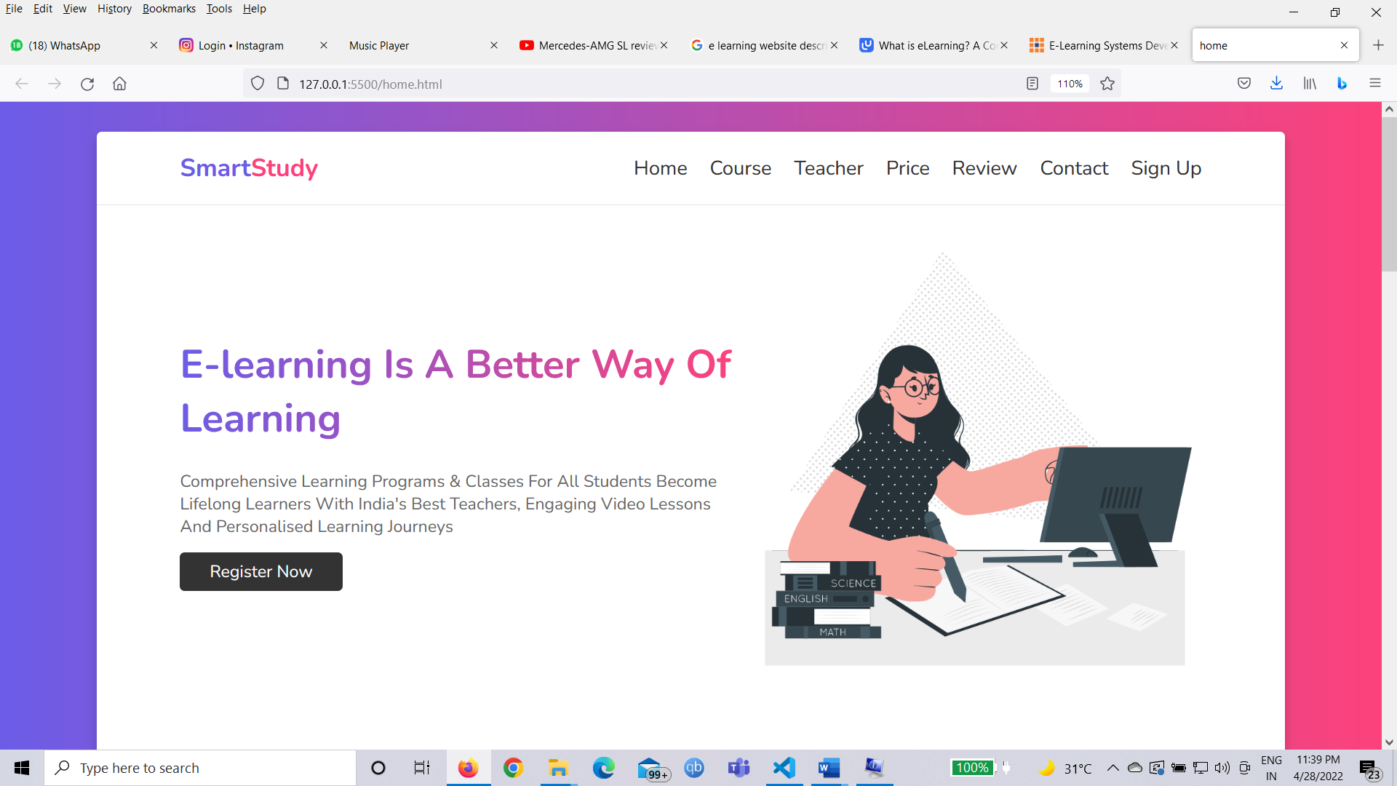

**Course Page:**

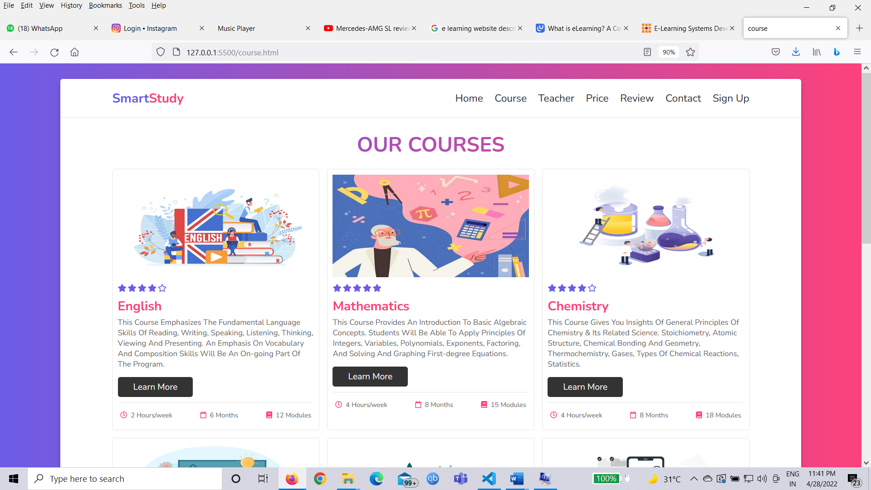

**Teacher Page:**

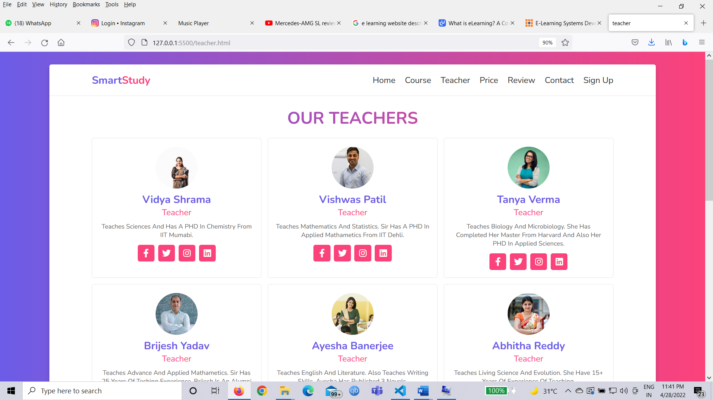

**Price Page:**

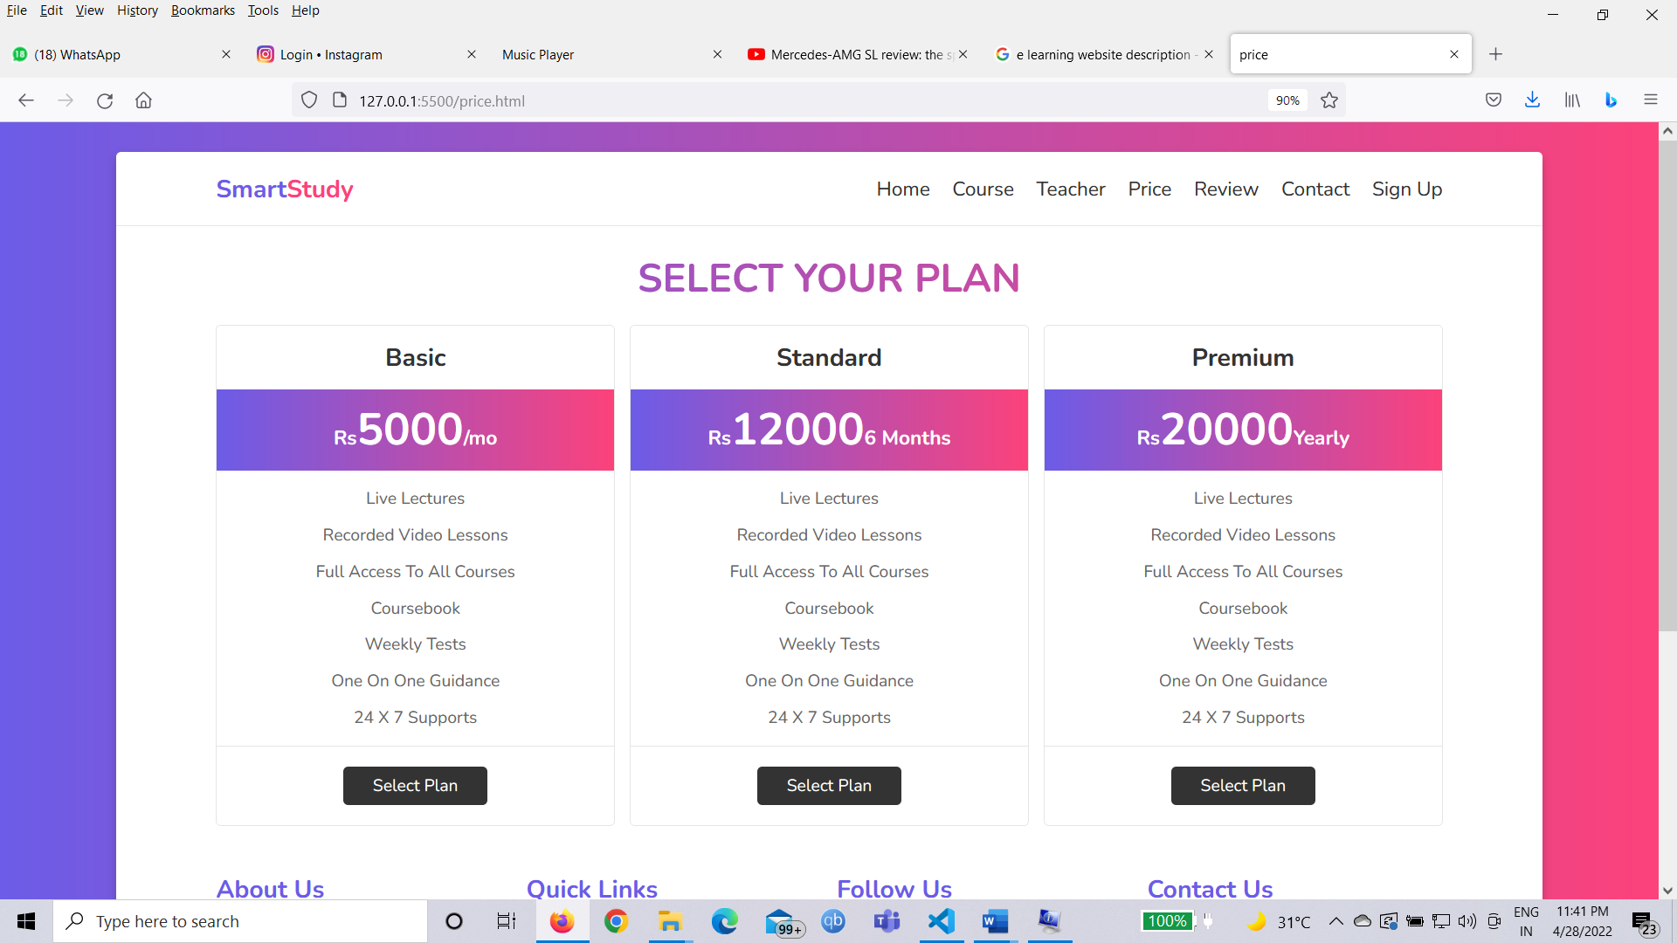

**Payment pages:**

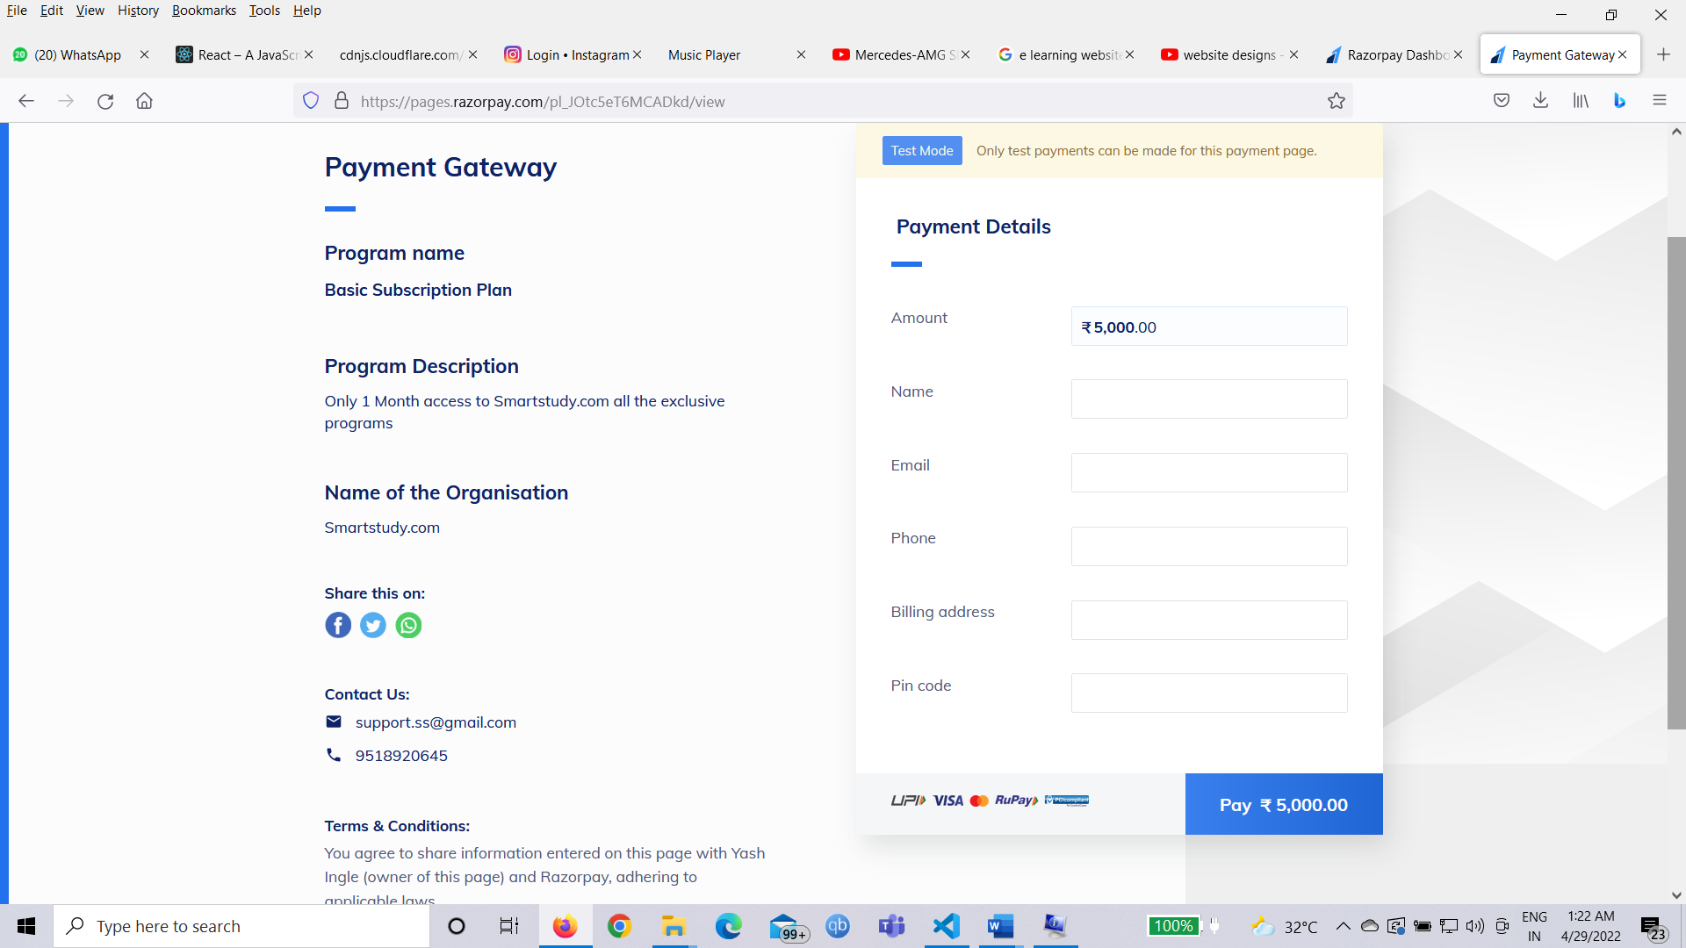

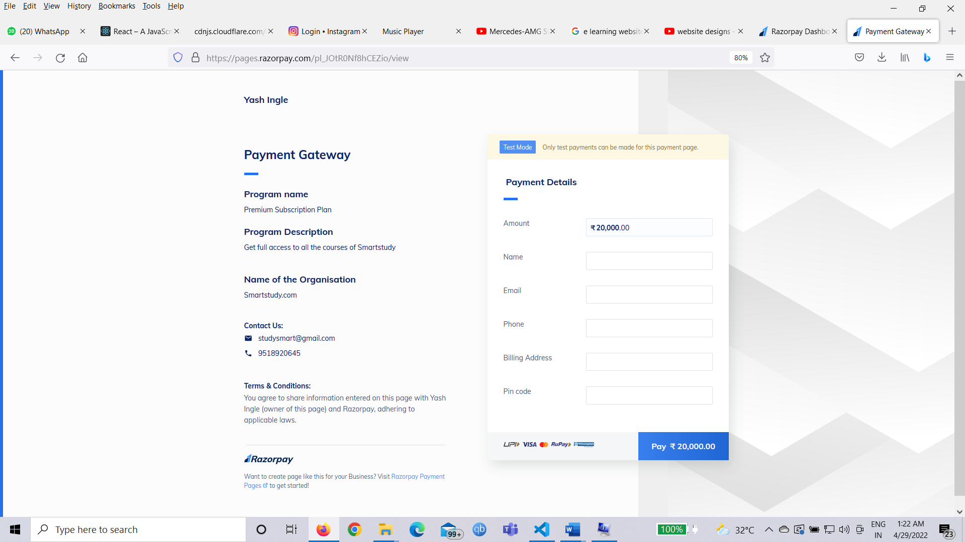

**Review Page:**

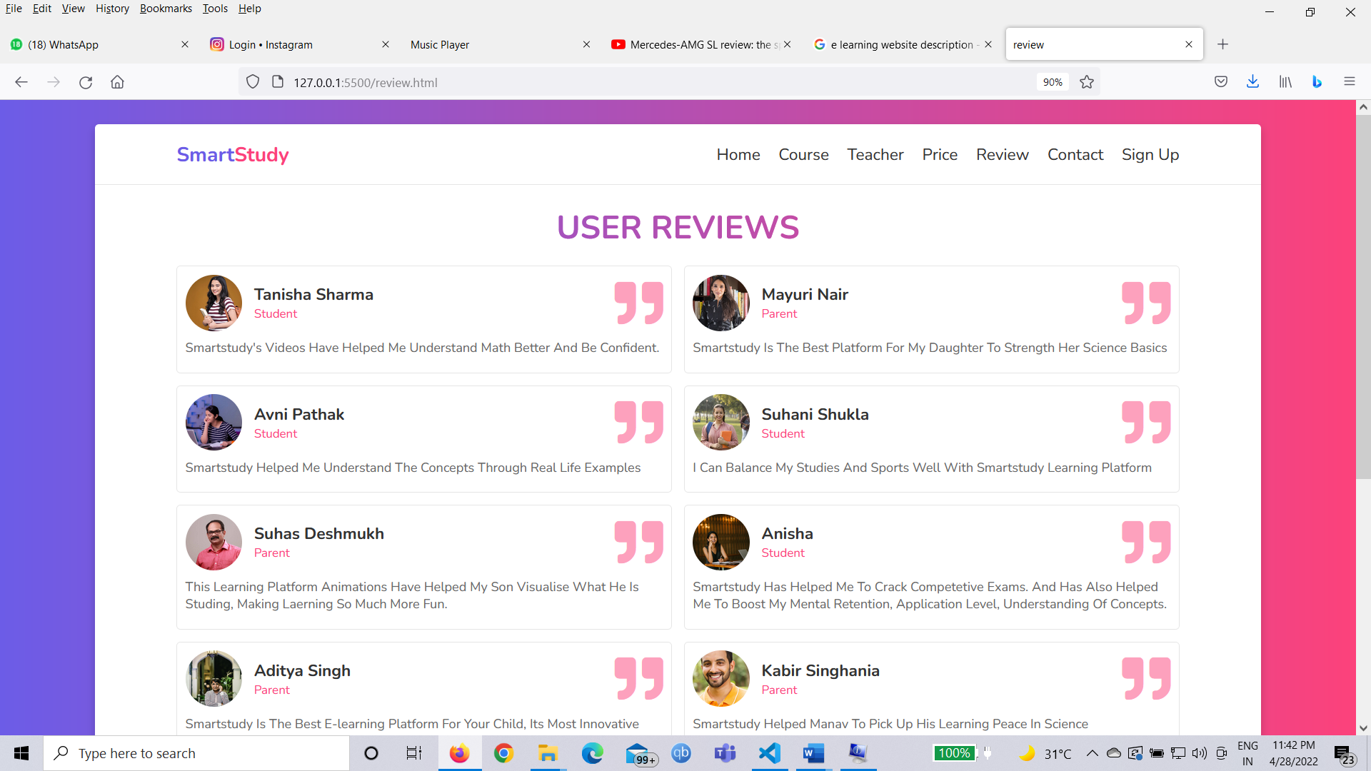

**Contact Page:**

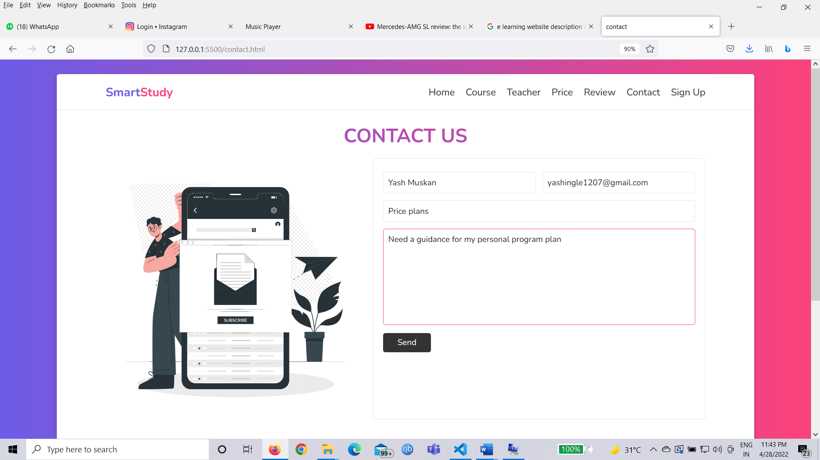

**Sign Up Page:**

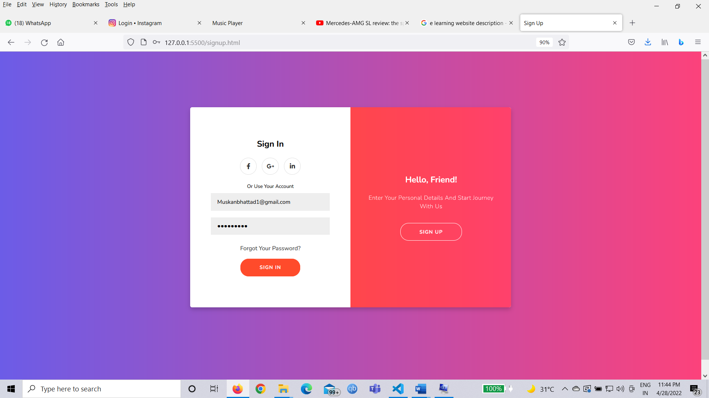

**New user registeration:**

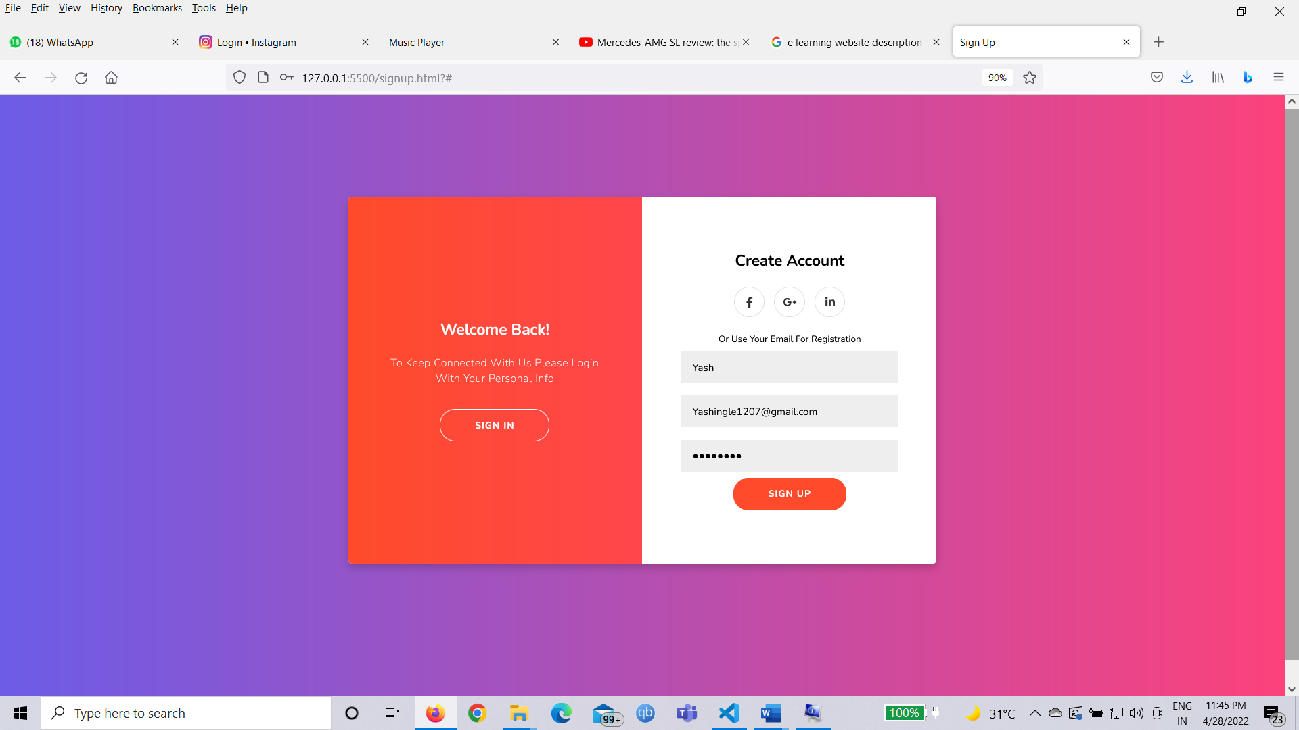

**RESULT**

Smartstudy.com is an E-learning platform where anyone can register and get access to the most advance study courses with cutting edge streaming technology. Anyone can visit the website go through all of the programs and courses available on the website and then click on particular program or can also buy a particular course as per their need.

If anyone wants to contact Smartstudy for any suggestions or any difficulty they are facing in our website then he/she can fill the contact us form and we will get back to him/her within 24 hours from submission of the form.

Our platform provides a feature of accessing education and skills anytime anywhere, that means we help our user to provide a service anytime, anywhere in any part of the world on just one click on their user window. They just have to visit our website and scroll through multiple programs which they need for their future career excellence also our one-to-one mentor career guidance session helps our user (students as well as professionals) to find the right path towards their goals. Users can also download these video lessons once they subscribe to our platform.

We provide flexible plans for every category of user also Smartstudy has flexible payment options integrated in it.

This website is made specially for all learners who are keen to learn new skills and love to follow their passion but aren’t able to find their right path and best access to world class mentors and teachers. Smartstudy fills that void and bridge the gap by providing user the best-in-class content with all other essential features. Smartstudy is one stop solution for all the learners.

**CONCLUSION**

E-learning is not just a change of technology. It is part of a redefinition of how we as a species transmit knowledge, skills, and values to younger generations of workers and students. Through this project we learned how HTML provides a basic structure of the page, upon which Cascading Style Sheets are overlaid to change its appearance.

In other words, an online learning platform is a webspace or portal for educational content and resources that offers a student everything they need in one place: lectures, resources, opportunities to meet and chat with other students, and more. It is also an excellent way for the student and the teacher to monitor student progress.

The language allows web developers to regulate various style elements and functionalities, like layout, color, fonts, and therefore the formatting and display of HTML documents. Where HTML and CSS are languages that give structure and style to web pages, JavaScript & React JS gives web pages interactive elements that engage a user and adds a great visual aid to your webpages.

**REFERENCES**

1. [**https://www.youtube.com/channel/UCKwgH3vASrD2brd1l2m6NHw**](https://www.youtube.com/channel/UCKwgH3vASrD2brd1l2m6NHw)
2. [**https://www.w3schools.com/html/**](https://www.w3schools.com/html/)
3. [**https://www.w3schools.com/w3css/defaulT.asp**](https://www.w3schools.com/w3css/defaulT.asp)
4. [**https://www.youtube.com/playlist?list=PLSJxovi1IyDFf36uSXsfQTmTVVFjAEkuo**](https://www.youtube.com/playlist?list=PLSJxovi1IyDFf36uSXsfQTmTVVFjAEkuo)
5. [**https://www.w3schools.com/css/css_website_layout.asp**](https://www.w3schools.com/css/css_website_layout.asp)
6. [**https://www.w3schools.com/w3css/w3css_fonts.asp**](https://www.w3schools.com/w3css/w3css_fonts.asp)
7. [**https://cdnjs.cloudflare.com/ajax/libs/font-awesome/5.15.3/css/all.min.css**](https://cdnjs.cloudflare.com/ajax/libs/font-awesome/5.15.3/css/all.min.css)
8. [**https://reactjs.org/**](https://reactjs.org/)